Logan Hammond

2 February 2020

SDEV 300, Fair

Lab 3 Results Document

# StateData

|  |  |  |  |  |
| --- | --- | --- | --- | --- |
| Test Case | Input | Expected Output | Actual Output | Pass? |
| 1a | 1 | List output containing all states and info. | List output containing all states and info. | Yes |
| 1b | 2, user input* | Capital and bird of state input. | Capital and bird of state input. | Yes |
| 1c | 3, user input* | Bird of specific state updated. | Bird of specific state updated. | Yes |
| 1d | 4 | Program exit. | Program exit. | Yes |

* User input is validated before execution.

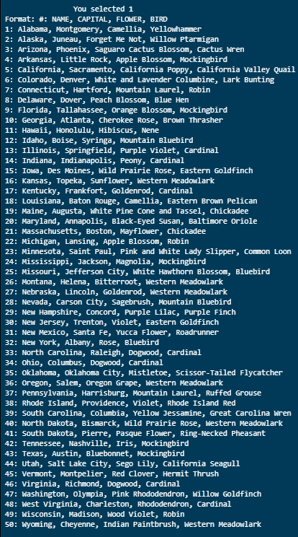

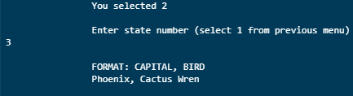

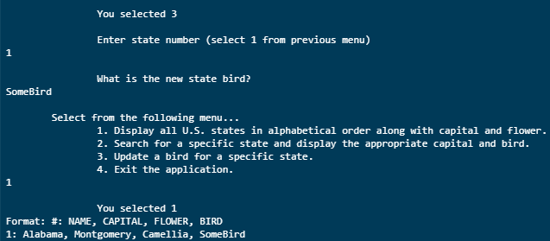

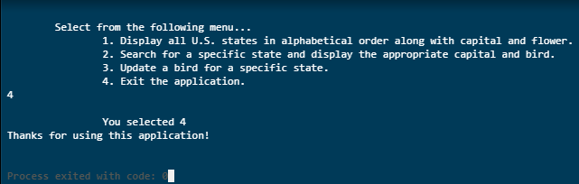

# SetTests

|  |  |  |  |  |
| --- | --- | --- | --- | --- |
| Test Case | Input | Expected Output | Actual Output | Pass? |
| 2a | 1 | Square and cube for integers 1-100 displayed. | Square and cube for integers 1-100 displayed. | Yes |
| 2b | 2, user input* | Square and cube of user input. | Square and cube of user input. | Yes |
| 2c | 3 | Union of square and cube sets | Union of square and cube sets. | Yes |
| 2d | 4 | Intersection of square and cube sets. | Intersection of square and cube sets. | Yes |
| 2e | 5 | Difference of square and cube sets. | Difference of square and cube sets. | Yes |
| 2f | 6 | Program exit. | Program exit. | Yes |

* User input is validated before execution.

